**Activity# 6**

**Step 1: Import Data**

Import data from file *Student.xml*. After importing the data, you’ll see the following table: 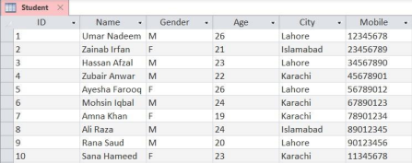

**Step 2: Write Queries**

After importing the data, design the following queries:

1. Display (select) all students who live in Karachi

2. Display all female students who live in Lahore or Islamabad

3. Display all female students who are younger than 24 years and live in Karachi 4. Insert a new student with the following data:

a. Name: Hira Jamil Gender: F Age: 25 City: Lahore Mobile: 22456789 5. Insert a new student in the table with the following data:

a. Name: Ali Amin Gender: M Age: 21 City: Karachi Mobile: 33567890 6. Display all male students who are younger than 23 years and live in Karachi 7. Update the age of student with ID 9 from 20 to 21

8. For student with ID 2, update city to Karachi and mobile number to 44678901 9. Delete all male students who are older than 23 years

10.Delete all female students who are younger than 20 years and live in Karachi **You can submit a simple text or word file containing all the queries.**